Web design Fundamentals   Year 1

College Project Report

Content

Declaration 3

GitHub link to my website 4

Website Proposal 4

Website Topic 4

Proposed Design 4

Proposed Design of each page’s content 4

Proposed sketch of the home page 4

Brief Description of My Website 4

Home Page 4

Czech Republic Page 4

Czechia Pages 4

Website Checklist Completed 4

HTML & CSS Validator Results 5

Home Page 5

Contact Form Page 5

Czechia Page 5

Czech Bucket-List Page 5

Czech Traditional Food Page 6

Czech Useful Phrases Page 6

Facts about Czechia Page 6

# Declaration

I the undersigned declare that the project material, which I now submit, is my own work. This material or project has not previously been submitted for any other assignment. Any assistance received by way of borrowing from previous work, or the work of others has been cited and acknowledged within the work. I make this declaration in the knowledge that a breach of the rules pertaining to project submission may carry serious consequences. We are aware that the project will not be accepted unless this form has been handed in along with the project.

Website Topic: Travel tips and information, basic and fun info about countries

Student name: Petra Poláková

Student number: S00239846

Date: 17/04/2023

# GitHub link to my website

<https://polakovap.github.io/WebSiteProject/>

# Website Proposal

## Website Topic

My website aims to help travelers get to know the countries they are visiting, along with some tips for places that are a total “must-see,” recommendations of traditional foods and drinks, and other interesting or important information.

## Proposed Design

The logo would be something connected to traveling so it would match the website’s topic, I am thinking maybe a plane or a globe.

There would be an interactive map in the middle of the page where you could click on the country to see the page with all the wanted information about this destination. I want to add a navigation menu as an alternative as well.

The original vision for colors is focused mostly on shades of blue but everything will be based on the used pictures and the whole content of the website, so it all matches nicely.

As an information source, I want to use some reliable websites focused on geography, travel bloggers, or even my own experience.

## Proposed Design of each page’s content

The main page would have a world map where you would choose the country.

The next page would focus on the country you have chosen and would have a menu of sections in which you can learn more about this specific country.

Next would be the page of the chosen section, for ex. traditional foods with some pictures and descriptions.

## Proposed sketch of the home page

# Brief Description of My Website

## Home Page

On the home page, you will find an interactive world map where you choose a country you want to visit. I chose to create only one country because it would take forever to create all of them and so I focused only on the Czech Republic. Even though you cannot really click other countries, once you point at them it will display the name of the country for you. Other than this there are two aside sections with some information about what Travel Buddy is and what were last year’s most visited countries globally. You will also find a button that will take you to a page with a contact form where you can sign up for a weekly newsletter with travel tips. At the bottom there is a footer navigation with a link to the Czech Republic page (as an alternative to the interactive map) alongside some other useful links.

## Czech Republic Page

This page is very simple yet interesting. You will find a short paragraph with some basic geographic information about this country and then you have the main part which is a menu consisting of 4 cards that will take you to the other pages once you click them. There is Bucket-List, Traditional Food, Useful Vocabulary, and 11 Interesting Facts. On the top of the page, you have a home button to get back to the home page.

## Czechia Pages

Any option from the menu on the CR page will take you to a new page with some specific type of information. All these pages have a header section in which you can see the logo, h1 with the website’s name, home page button, and back button that will take you back to the CR page.

On the Bucket-List page, you will see 3 sections that are bordered with a transparent background and the last section consists of a google maps iframe showing the location of Prague.

On the Foods page, you find on section with a bunch of traditional foods/drinks where each has a picture. All the pictures are aligned and sized the same way, so everything looks nice and smooth. When you scroll to the bottom of the page, you will also see a back-to-top button.

On the Vocab page, I used a table of data to create a short dictionary of useful words and phrases for travelers to learn before their visit.

And the last page consists of a video with some interesting facts, I added it using the <video> tag but since I found this video on YouTube, I also put a link underneath to take you to the original.

# Website Checklist Completed

|  |
| --- |
| **\*\*\* GitHub URL Progress upload of web site navigation and 3 pages – Week9** |
| **Project Report, Upload zipped folders all website files with report, (place college project on front page, no personal information to be included)** |
| **Minimum of 4 HTML Page Website** |
| **HTML5 standards and recommended page layout structure** (header,main,aside,article,section,footer) |
| **Include Meta data – description, keywords, viewport - Maximise SEO** |
| **Include font family for body of page** |
| **Appropriate use of External Style Sheet – Recommended CSS** |
| **Appropriate Example using Internal Styling on HTML page** (an example) |
| **Appropriate Example using use of inline Styling** (an example) |
| **Home page content aligned to each other and visually attractive** |
| **Consistency of design on all pages above fold, aligned, use of fonts, colour etc.** |
| **Appropriate use of Headings (h1, h2, h3, h4)** |
| **Appropriate use of Colours, easy to read and complimentary colours** |
| **Include an article or section with CSS that displays 2 or 3 columns** |
| **Clear, consistent and align content on page (reference all sources)** |
| **Include public domain images ,with at least one image floated with text** Public Domain or Creative Commons License Images from advanced search |
| **Use of background image** |
| **Include table of data/information** |
| **Include lists of content with ordered and unordered display**  use different shaped bullet |
| **Include favicon and logo on your website** |
| **Include a contact form Display values entered in form and include red * beside required/mandatory input fields** |
| **Verify data collected on contact form, using get and data attached to URL** (Use the method get to display values entered on form will be appended to url and passed to server <form <action="http://foo.com" method="get">) |
| **Include google maps and suitable video** (include reference if YouTube videos are used) |
| **Footer information include** Copyright© year **and a footer navigation menu** |
| **Include Internal Links and External Links – Responsive webpages(70%)** |
| **Include Appropriate use of CSS Class and Id selectors** |
| **Additional Features not covered in class exercises__________________** |
| **W3C HTML & CSS Validator results (in report)** <https://validator.w3.org/nu/#file> |
| **Report include Proposal, Declaration of your own work , URL to Github, Rough Sketch of layout design, brief descriptions of the web site its pages and sources for information and Validator results** |
| **Website appearance, design and Content** [**https://webdesignledger.com/10-signs-of-a-user-focused-design/**](https://webdesignledger.com/10-signs-of-a-user-focused-design/)[**https://webdesignledger.com/20-dos-and-donts-of-effective-web-design/**](https://webdesignledger.com/20-dos-and-donts-of-effective-web-design/) |

# HTML & CSS Validator Results

## Home Page

## Contact Form Page

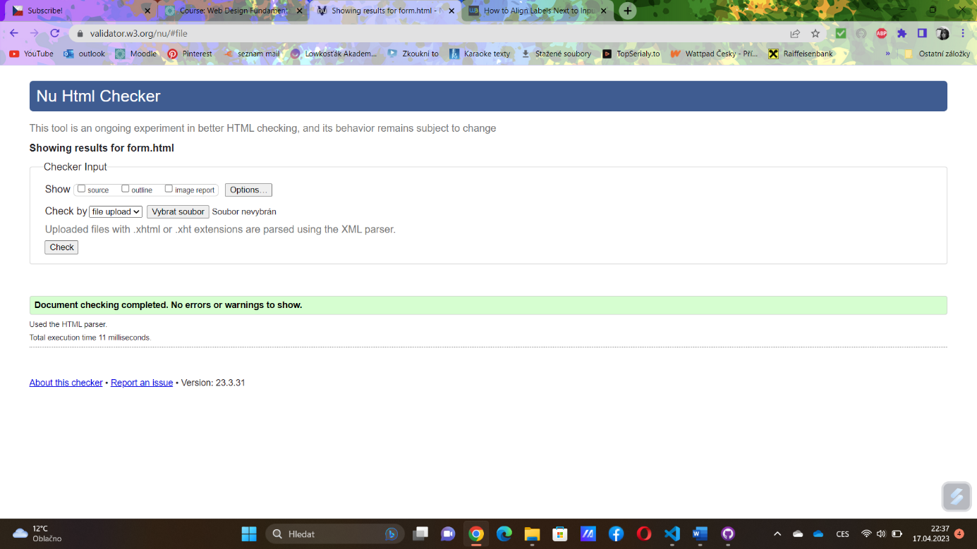

## Czechia Page

## Czech Bucket-List Page

## Czech Traditional Food Page

## Czech Useful Phrases Page

## Facts about Czechia Page

